**Baltic Infoday 2014**

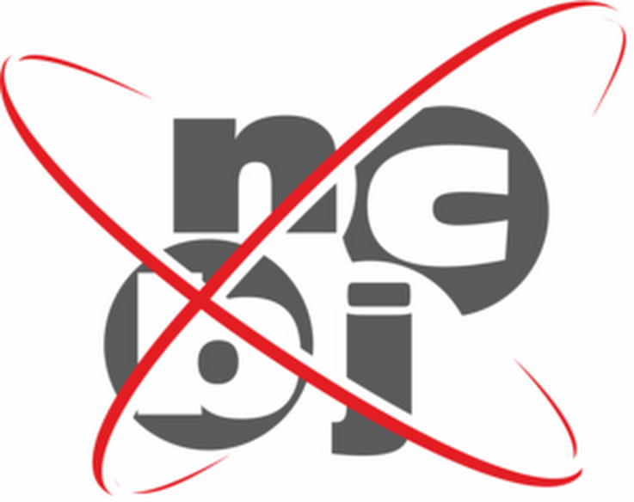

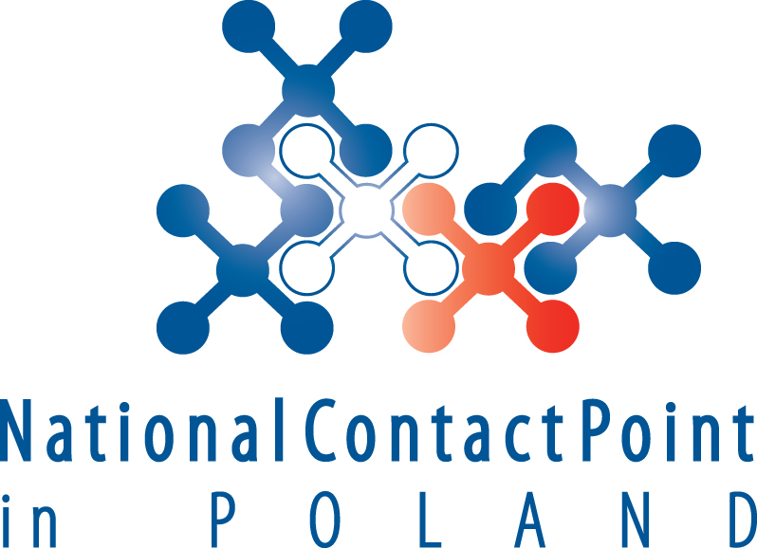

**Euratom-Fission in Horizon 2020**

**03.06.2014**

National Contact Point for Research Programmes of the EU

Pawińskiego 5b, Warsaw, Poland

Agenda

|  |  |
| --- | --- |
| 10:00 - 10:20 | **Welcome and introduction to Horizon 2020 Programme,**  Ewa Szkiłądź, Katarzyna Sobótka-Demianowska, NCP-Poland |
| 10:00 - 11:20 | **Euratom-Fission in Horizon 2020**  Roger Garbil, European Commission |
| 11:20 – 11:50 | **How to succeed in Horizon 2020**  Grzegorz Wrochna, NCBJ |
| 11:50 - 12:20 | Coffee break |
| 12:20 – 13:00 | **Rules of participation in Euratom-Fission**  Roger Garbil, European Commission |
| 13:00 – 13:20 | **Nuclear activities of Joint Research Center**  Adam Głuszuk, NCP-Poland |
| 13:20 - 13:50 | **Euratom Success Stories**  Andrzej Chmielewski, ICHTJ  Representative of NCBJ (tbc) |
| 13:50 – 14:00 | **KIC InnoEnergy**  Marek Marzec, KIC InnoEnergy CC Poland Plus |
| 14:00 – 14:30 | **Research Infrastructures for nuclear activities**  Wieslaw Studencki, NCP- Poland |