# “Space Weather & Critical Infrastructures”

***Organisers*** ***Date and Venue***

EC JRC, MSB, UK Met Office 29-30 November 2016, JRC Ispra, Italy

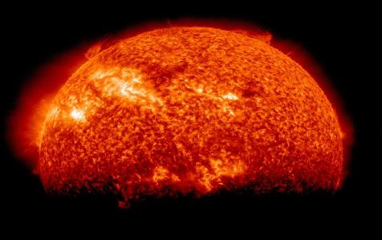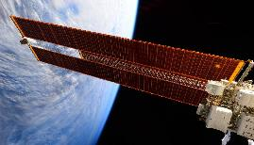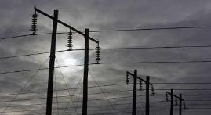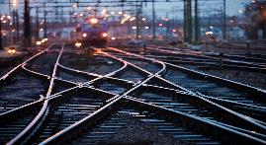

## Background

Our modern technological infrastructures on the ground and in space are vulnerable to the effects of natural hazards. Of increasing concern is extreme space weather that can have serious impacts on space- or ground-based infrastructures. Space weather occurs across national boundaries, and crises in one country can easily spill over to neighbouring critical infrastructure networks. Transboundary failures can lead to very long recovery lead times. Numerous space-weather impacts to the power grid, aviation, communication, and navigation systems have already been observed and documented. Since society relies increasingly on the services these critical infrastructures provide, awareness of the space weather threat needs to be created and the risks from extreme space weather should be assessed to ensure adequate preparedness of infrastructure operators and society in general.

Research efforts, in particular in North America and the EU, have been launched to better understand the impact of space weather on different types of critical infrastructures and to identify potential risk-reduction measures. In parallel, awareness raising initiatives have engaged stakeholders related to power-grid operations, aviation, financial systems, rail transport, and crisis response to trigger a process that will increase the resilience of infrastructure systems with respect to space weather.

Five years ago, the European Commission organised a space-weather workshop “A Space Weather Dialogue” to increase awareness across countries and across sectors. This workshop aims to take stock of space-weather risk reduction efforts in the EU over the past 5 years and identify remaining gaps that still need to be addressed. The workshop will continue to increase awareness of space-weather impacts among the stakeholders, and it will encourage continued efforts towards risk assessment, preparedness and targeted response.

## Audience and objectives

While the focus of this summit will be primarily the EU, international participation, in particular from the US, will also be sought in light of the recent publication of the US National Space Weather Strategy. Participants are expected to represent diverse stakeholder groups, such as government (decision makers, crisis managers), industry, and the scientific and engineering communities.

The overall objectives of the workshop are to:

* Raise awareness of potential space-weather impacts on critical infrastructures among the stakeholder groups.
* Present the known vulnerabilities of different types of critical infrastructures and discuss the potentially resulting problems with respect to service disruption and cascading effects.
* Discuss how industry and government can prevent incidents and prepare for their consequences both from a sectoral and holistic point of view.
* Identify remaining needs and gaps in risk reduction with respect to space weather impacts and recommend a way forward.
* Promote and support dialogue, exchange of information and coordination among the stakeholders to foster a holistic approach towards disaster risk reduction associated with extreme space weather storms.

***Draft Programme***

**29-30 November, Ispra, Italy**

**DAY 1**

**8:45 – 9:00 Opening and welcome** (*D. Chirondojan, JRC*)

**9:00 – 11:00 Space weather today and progress made**

*Chair: M. Gibbs, UK Met Office*

* Introduction to space weather (*B. Murtagh,* *NOAA*)
* Space weather and disaster risk reduction (*DG ECHO, represented by I. Clark, now JRC*)
* Awareness, policy action and international cooperation for space weather: progress over the past 5 years
  + Developments in the EU – FP7 and H2020 (*V. Bothmer, Göttingen University*)
  + Space Situational Awareness programme (*J.-P. Luntama, ESA*)
  + US National Space Weather Strategy (*C. Cannizzaro, US Dept. of State*)
  + COSPAR Space Weather Roadmap (*H. Opgenoorth, Swedish Institute of Space Physics*)

***11:00 – 11:15 Coffee break***

**11:15 – 12:30 Space-weather impacts on critical infrastructures and risk reduction: Part I**

*Chair: W. Murtagh, NOAA*

* Known vulnerabilities of CIs to space weather and risk reduction:
  + Power grid (*A. Richards, UK National Grid*)
  + Aviation (*B. Jones, SolarMetrics Consulting*)
  + GNSS (*J. Fortuny-Guasch, JRC*)
  + Rail *(L. McCormack,* *Atkins*)

***12:30 – 13:30 Lunch***

**13:30 – 14:45 Space-weather impacts on critical infrastructures and risk reduction: Part II**

*Chair: S. Jonas, US Science and Technology Policy Institute*

* National approaches to space weather risk management: Sweden (*C. Goede,* *MSB*)
* National approaches to space weather risk management: UK (*C. Lally,* *UK Government Office for Science)*
* US forecasting and alert capabilities (*B. Murtagh,* *NOAA*)
* UK forecasting and alert capabilities (*M. Gibbs, UK Met Office*)

***14:45 – 15:15 Coffee break***

**15:15 – 18:00 Table top exercise Part 1 – Gap analysis**

*Moderators: M. Gibbs, UK Met Office, H. Opgenoorth, Swedish Institute of Space Physics*

Experts have spotted an Earth directed CME. What additional measures and capabilities are required to protect infrastructures and the population?

* Which additional structural and organisational measures for risk reduction in industry are required?
* What are operator requirements for continued operability and constraints to respond to such an event?
* Which additional observational and modelling capabilities are needed to improve forecasting?
* In case of an alert, how is information shared with the public and private actors?

***19:30 Social dinner***

**DAY 2**

**9:00 – 10:15 Interdependencies and crisis response**

*Chair: N. Kourti, JRC*

* CIP initiatives in Europe, interdependencies and cascading effects (*L. Galbusera, JRC*)
* Transboundary effects (*N. Komendantova*, *IIASA*)
* Lessons learned from UK space-weather emergency exercise (*C. Lally, UK Government Office for Science*)

***10:15 – 10:45 Coffee break***

**10:45 – 13:00 Table top exercise Part 2 – Impact analysis and crisis response**

*Moderator: I. Clark, JRC*

The extreme space weather event caused a number of power outages across Europe and has resulted in loss of GNSS services across much of Europe. The impact is spreading across sectors. Identify potential deficiencies in the crisis management and the measures required to create robust infrastructure and redundancy in society.

* What are the societal impacts of an extreme space weather event?
* Which are the common challenges the Member States and the EU will have to address in such an event?
* Are additional emergency planning and response capabilities needed?

***13:00 – 14:15 Lunch***

**14:15 – 15:15 The way forward**

*Chair: W. Murtagh, NOAA*

*Panel members: I. Clark (JRC, tbc), M. Gibbs (UK Met Office), C. Canizzaro (US Dept. of State), H. Opgenoorth (Swedish Inst. of Space Physics)*

* Summary of recommendations to close gaps (feedback from Table Top exercise)
* Mechanisms for collaboration between countries (bilateral and multilateral)
* Identification of common capabilities that need to be developed
* Discussion of next steps

**15:15 – 15:30 Closing of the event**