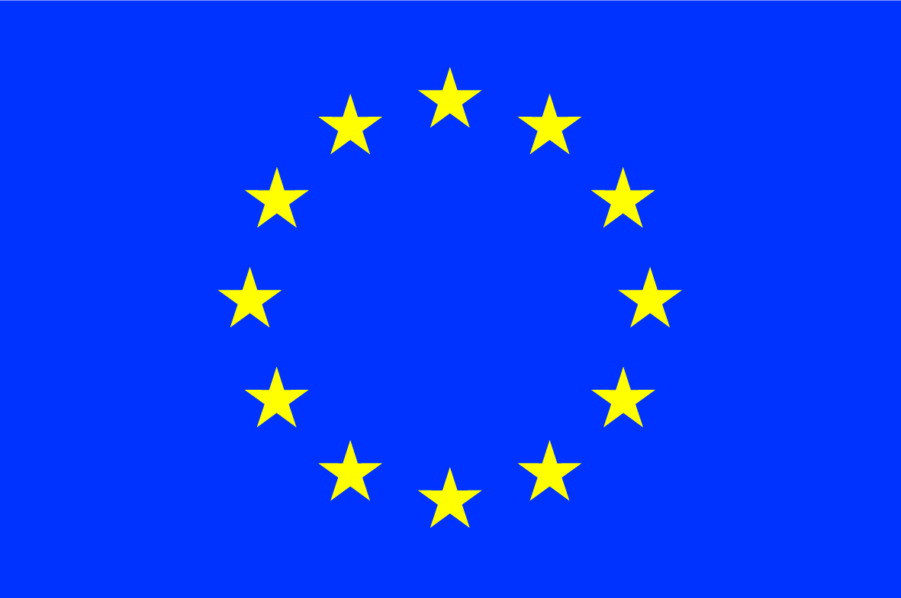
INFODAY

Spreading Excellence and Widening Participation in Horizon 2020

Tuesday 15 June 2017
14.00 – 17.30

Madou Tower (1, Place Madou, B-1210 Brussels), Auditorium

Agenda
14:00 Registration

14:30 Welcome address
JD MALO, Director, European Commission, DG Research and Innovation (RTD)

14:40 Widening - general overview
Magda DE CARLI, Head of Unit, DG RTDB.5

15:00 Lessons learnt from Widening calls (2014-16)
Peter Van der ZANDT, Head of Unit, REA B.5

15.20 ERA Chairs call
Adeline KROLL, Policy Officer, DG RTD

15:40 Twinning call
Joao Silva ALBUQUERQUE, Policy Officer, DG RTD

16.00 Coffee break

16.15 Opportunities provided by COST
Stefan WEIERS, Deputy Head of Unit, DG RTDB.5
Katalin ALFOLDI, Policy Officer, COST

16.45 Presentation from the Widening NCP network
Ms Katarzyna WALCZYK (Polish NCP)

17:00 Questions and conclusions

17:30 End of meeting

